[2022-07-26] AR/QCA/MTK Breed, a powerful multi-threaded bootloader
This post was last edited by hackpascal on 2022-07-26 19:14
https://www.right.com.cn/forum/thread-161906-1-1.html

Important reminder:
Subsequent Breed update logs and supplementary instructions will be published first on
https://blog.hackpascal.net/
If you have any questions, you can leave a message here

Latest updates:
https://blog.hackpascal.net/2022/07/2022-07-24-breed-update/

Refuse to reach out to the party
If you want dedicated Breed for a certain device, you have to provide the corresponding device, otherwise there is no need to talk about it. It doesn't matter to me whether you do it or not.
This is a brand-new Bootloader designed and developed by the author since the middle of last year, and is used to replace U-Boot.
This Bootloader is temporarily named Breed. It is not U-Boot, nor is it an improved version of U-Boot. It is a brand new, independent Bootloader on the same level as U-Boot.

Popular science:
Bootloader means boot loader, which is a program used to load the operating system. It is the collective name for a large class of such functional programs. Today's BIOS, UEFI, GRUB, RedBoot, U-Boot, CFE, Breed, etc. are all Bootloaders.
Therefore, as mentioned above, Breed was not renamed from something, it is a new thing. I really find it funny when I look at what some people say.
In addition, from the above two sentences, if you want to flash from Breed to any other bootloader, such as U-Boot, please choose to update the bootloader on the Breed firmware update page.

Free, unlimited, not open source

Special reminder: "Immortal" means that all firmware update operations are completed in Breed. Because some official upgrade firmware comes with a Bootloader, if you upgrade from the official firmware Web, Breed will be overwritten. When Breed flashes the firmware The Bootloader that comes with the firmware will be automatically removed, thus ensuring that Breed itself is "immortal".

Breed does not support booting non-Linux firmware, such as TP/Mercury/Swift VxWorks systems. Therefore, if the firmware size is less than or equal to 2MB, it will definitely not be flashed.

Breed cannot intelligently identify [any] firmware, and the firmware that can be supported requires writing code to judge. It is not possible for people to know where the firmware is at a glance...

Breed has the following new features:

- Real-time flashing progress, the progress bar can accurately reflect the flashing progress
- Fast response of web pages
- Maximum firmware backup speed, depending on Flash, generally reaches 1MB/s
- Enter web flash mode without pressing the reset button
- Telnet function, TTL-free access to Breed command console
- Reset key defines test function
- Firmware startup fails and automatically enters Web flash mode
- Environment variable blocks with customizable position and size

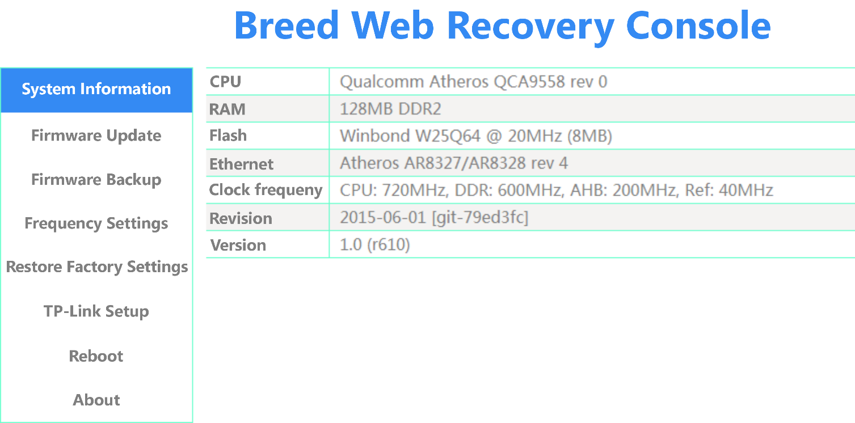
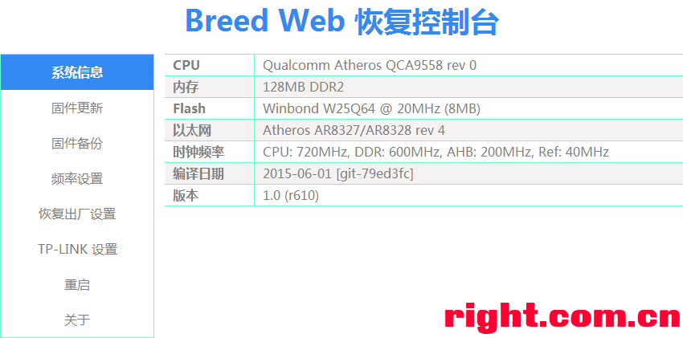

Content of this post
2nd Chapter – Changelog
3rd Chapter – Applicable models and Flash instructions
4th Chapter – Breed command console instructions and TTL flashing
5th Chapter – Reset Button Test Instructions
6th Chapter – Environment variable description, custom reset button description, Xiaomi Mini firmware startup settings

Enter Web flash mode
Computer network connection is set to obtain an IP address automatically
Open CMD and run ping 192.168.1.1 -t
Note that starting from r979, this IP address can be modified, so in actual operation, it needs to be replaced with the modified IP
Press and hold the reset button or WPS button and then power on the router. If you see some or all of the router's LEDs flashing 4 times in a row, or pinging successfully, it means it has entered web flash mode.

Enter Web flash mode without pressing the reset button
Implemented through The BreedEnter tool (requires Npcap)
https://github.com/nmap/npcap/releases/
https://github.com/nmap/npcap/releases/download/v0.10-r7/npcap-0.10-r7.exe
Download Npcap, install in WinPcap compatibility mode
Let’s support Windows XP
Click here to download the Windows XP-specific beta version of BreedEnter (compiled using WDK 7.1.0):
http://breed.hackpascal.net/BreedEnter-VC80-XP.zip

Make sure the router is connected to the computer via a network cable
1. Run BreedEnter.exe
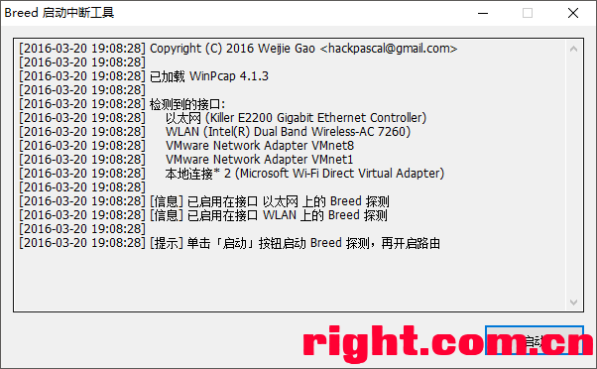

2. Power off and then power on the router
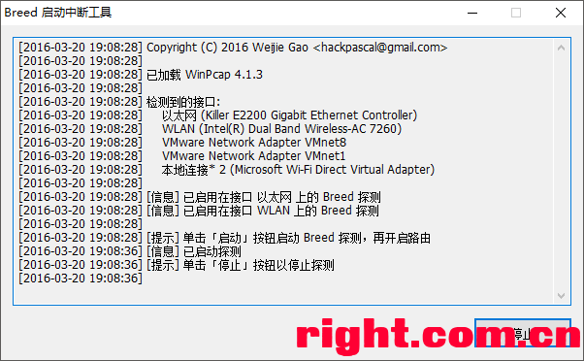

3. If the program interface prompts as follows, it means that it has entered the Web flash mode
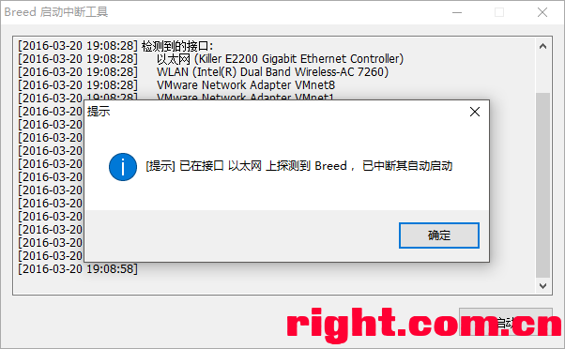

Modify serial port baud rate
- Enter the Breed command console
- Execute the command setbrg <baud rate>
- Restart takes effect

File description
Breed files that are no longer updated have been moved to https://breed.hackpascal.net/EOL/
and the last revision number will be indicated after the file name.

Filename | Description
BreedEnter.exe | Breed Enter the interrupt tool to enter the web flash mode without pressing the reset button.
md5sum.txt | MD5 values of all Breed files in the current version, used to verify file integrity
breed-mt7620-reset1.bin | MT7620A / MT7620N Fully universal, baud rate 57600, reset button GPIO#1
breed-mt7620-reset2.bin | MT7620A / MT7620N Fully universal, baud rate 57600, reset button GPIO#2
breed-mt7620-reset11.bin | MT7620A / MT7620N Fully universal, baud rate 57600, reset button GPIO#11
breed-mt7620-reset12.bin | MT7620A / MT7620N Fully universal, baud rate 57600, reset button GPIO#12
breed-mt7620-reset13.bin | MT7620A / MT7620N Fully universal, baud rate 57600, reset button GPIO#13
breed-mt7620-reset26.bin | MT7620A / MT7620N Fully universal, baud rate 57600, reset button GPIO#26
breed-mt7620-reset30.bin | MT7620A / MT7620N Fully universal, baud rate 57600, reset button GPIO#30
breed-mt7620-rt-n14u.bin | MT7620A / MT7620N Fully universal, baud rate 57600, reset button GPIO#1, WPS key GPIO#2
breed-mt7620-whr-1166dhp.bin | MT7620A / MT7620N Fully universal, baud rate 57600, reset button GPIO#52, AOSS key GPIO#53
breed-mt7620-lenovo-y1.bin | For Lenovo Y1 (newifi mini), baud rate 115200, reset button GPIO#11
breed-mt7620-lenovo-y1s.bin | Lenovo Y1S (newifi) dedicated, Gigabit port available, baud rate 115200, reset button GPIO#11
breed-mt7620-zte-q7.bin | ZTE Q7 Dedicated, baud rate 57600, reset button GPIO#26
breed-mt7620-youku-yk1.bin | Special for Youku Router, Baud rate 57600, reset button GPIO#1
breed-mt7620-xiaomi-mini.bin | Exclusively for Xiaomi Mini, baud rate 115200, reset button GPIO#30
breed-mt7620-fir302m.bin | Fiji News FIR300M/302M Dedicated, baud rate 57600, reset button GPIO#2
breed-mt7620-phicomm-psg1208.bin | Fiji News PSG1208 (K1) / PSG1218 (K2) Dedicated, baud rate 57600, reset button GPIO#1
breed-mt7620-hiwifi-hc5761.bin | Extreme routing Extreme one S (HC5661) / Extreme two (HC5761) dedicated, baud rate 115200, reset button GPIO#12
breed-mt7620-hiwifi-hc5861.bin | Pole Router Pole San (HC5861) dedicated, Gigabit LAN available, baud rate 115200, reset button GPIO#12
breed-mt7620-oye-0001.bin | Oh yeah Oye-0001 dedicated, baud rate 115200, reset button GPIO#1
breed-mt7620-airmobi-iplay2.bin | AirMobi iPlay2 Dedicated, baud rate 57600, reset button GPIO#26
breed-mt7621-newifi-d1.bin | Dedicated to Lenovo Newifi D1, suitable for DDR3 memory, default 256MB DDR AC timing parameters, baud rate 115200, reset button GPIO#15, WPS button GPIO#18
breed-mt7621-newifi-d2.bin | Dedicated to Lenovo Newifi D2, suitable for DDR3 memory, default 512MB DDR AC timing parameters, baud rate 115200, reset button GPIO#3, WPS button GPIO#7
breed-mt7621-xunlei-timeplug.bin | Dedicated to Thunder Time Machine (Time Cloud), suitable for DDR3 memory, default 256MB DDR AC timing parameters, baud rate 115200, reset button GPIO#4
breed-mt7621-youku-l2.bin | Special for Youku Router YK-L2, suitable for DDR3 memory, default 256MB DDR AC timing parameters, baud rate 115200, reset button GPIO#18, WPS button GPIO#17
breed-mt7621-phicomm-k2p.bin | Fiji News K2P dedicated, DDR3 memory applicable, default 512MB DDR AC timing parameters, Baud rate 57600, reset button GPIO#3
breed-mt7621-pbr-m1.bin | PandoraBox PBR-M1 dedicated, DDR3 memory suitable, default 512MB DDR AC timing parameters, baud rate 115200, reset button GPIO#18
breed-mt7621-totolink-a3004ns.bin | TOTOLINK A3004NS dedicated, DDR3 memory suitable, default 256MB DDR AC timing parameters, Baud rate 57600, reset button GPIO#4, WPS key GPIO#3
breed-mt7621-xiaomi-r3g.bin | Xiaomi router 3G dedicated, NAND boot, DDR3 memory suitable, default 256MB DDR AC timing parameters, baud rate 115200, reset button GPIO#18
breed-mt7621-creativebox-v1.bin | CreativeBox v1 dedicated, DDR3 memory suitable, default 512MB DDR AC timing parameters, baud rate 115200, reset button GPIO#18
breed-mt7621-hiwifi-hc5962.bin | Extreme router 4/HC5962/B70 dedicated, NAND boot, DDR3 memory applicable, default 256MB DDR AC timing parameters, baud rate 115200, reset button GPIO#18
breed-mt7621-r6220.bin | Netgear R6220 dedicated, NAND boot, DDR2 memory suitable, fixed 128MB DDR AC timing parameters, Baud rate 57600, reset button GPIO#14, WPS button GPIO#7, RFKILL button GPIO#8
breed-mt7621-wndr3700v5.bin | Netgear WNDR3700 v5 dedicated, DDR2 memory suitable, fixed 128MB DDR AC timing parameters, Baud rate 57600, reset button GPIO#14, WPS key GPIO#7, RFKILL key GPIO#8
breed-mt7621-gehua-ghl-r-001.bin | Dedicated to Gehua GHL-R-001, suitable for DDR3 memory, default 512MB DDR AC timing parameters, Baud rate 57600, reset button GPIO#18
breed-mt7621-jd-cloud-1.bin | Special for JD Cloud Router RE-SP-01B, suitable for DDR3 memory, default 512MB DDR AC timing parameters, baud rate 115200, reset button GPIO#18
breed-mt7628-hiwifi-hc5661a.bin | Ji Routing Ji Yi S (HC5661A) dedicated, baud rate 115200, reset button GPIO#38
breed-mt7628-oye-0006.bin | Oh yeah OYE-0006 dedicated, baud rate 115200, reset button GPIO#38
breed-mt7688-reset38.bin | MT7628AN/KN Fully universal, baud rate 57600, reset button GPIO#38
breed-mt7688-wrtnode2r.bin | MT7628AN/KN fully universal, baud rate 115200, reset button GPIO#5
breed-rt3050-buffalo-wcr-hp-gn.bin | Buffalo WCR-HP-GN dedicated, SPI boot, Baud rate 57600, reset button GPIO#10, WPS key GPIO#0
breed-rt3050-di-524m-b1.bin | D-Link DI-624M B1 dedicated, SPI boot, Baud rate 57600, reset button GPIO#10
breed-rt305x-nor-reset0.bin | RT305X general purpose, NOR boot, Baud rate 57600, reset button GPIO#0
breed-rt305x-nor-reset10.bin | RT305X general purpose, NOR boot, Baud rate 57600, reset button GPIO#10
breed-rt3052-dir-605-b1.bin | D-Link DIR-605 B1 dedicated, NOR boot, Baud rate 57600, reset button GPIO#10, WPS key GPIO#0
breed-rt3052-hg255d.bin | Dedicated to Huawei HG255D, NOR boot, baud rate 115200, reset button GPIO#4, WPS button GPIO#10
breed-rt5350-airmobi-iplay.bin | AirMobi iPlay Dedicated, baud rate 57600, reset button GPIO#12
breed-rt5350-hame-a5.bin | Huamei A5 Dedicated, baud rate 57600, reset button GPIO#0
breed-rt5350-zm-10.bin | Zhongwo ZM-10 Dedicated, baud rate 57600, reset button GPIO#10
breed-ar7161-dir-825-b1.bin | D-Link DIR-825 B1 dedicated, baud rate 115200, reset button GPIO#3, WPS button GPIO#8
breed-ar724x.bin | AR724X Universal, 100M wired, baud rate 115200, reset button GPIO#11, QSS key GPIO#12
breed-ar724x-reset11.bin | AR724X Universal, 100M wired, baud rate 115200, reset button GPIO#11
breed-ar724x-reset12.bin | AR724X Universal, 100M wired, baud rate 115200, reset button GPIO#12
breed-ar7240-wnr1000v2.bin | Netgear WNR1000 v2 dedicated, 100M wired, baud rate 115200
breed-ar7242-wr2543nd.bin | TP-Link WR2543ND dedicated, baud rate 115200, reset key GPIO#11, QSS key GPIO#12
breed-ar7242-aruba-ap93.bin | Aruba-AP93 dedicated, Gigabit wired, baud rate 115200, reset button GPIO#11, WPS button GPIO#12
breed-ar913x.bin | AR913X Universal, 100M wired, baud rate 115200, reset button GPIO#7, WPS key GPIO#3
breed-ar9132-wr1043ndv1.bin | TP-Link WR1043ND v1 dedicated, baud rate 115200, reset button GPIO#7, WPS button GPIO#3
breed-ar9331.bin | AR9331 Universal, baud rate 115200, reset button GPIO#11
breed-ar9331-mr12u.bin | TP-Link MR12U dedicated, baud rate 115200, reset button GPIO#11
breed-ar9331-pisen.bin | Pinsheng cloud router (cloud base easy to charge WMM003N/wireless music router WPR001N) dedicated, baud rate 115200, reset button GPIO#12
breed-ar9331-wr710n.bin | TP-Link WR710N/WR720N v3 dedicated, baud rate 115200, reset button GPIO#11
breed-ar9331-hiwifi-hc6361.bin | Jirouter Jiyi (HC6361) is dedicated, only supports TP class firmware, baud rate 115200, reset button GPIO#11
breed-ar9341.bin | AR9341 Universal, baud rate 115200, reset button GPIO#17
breed-ar9341-wnr2000v4.bin | Netgear WNR2000 v4 dedicated, baud rate 115200, reset button GPIO#4
breed-ar9341-pisen-wmp002n.bin | Pinshengyunzhuiju WMP002N dedicated, baud rate 115200, reset button GPIO#17
breed-ar9341-wr800n.bin | TP-Link WR800N dedicated, baud rate 115200, reset button GPIO#18
breed-ar9342-wr1041nv2.bin | TP-Link WR1042N v2 dedicated, baud rate 115200, reset button GPIO#14
breed-ar9342-huawei-ws322.bin | For Huawei WS322, baud rate 115200, reset button GPIO#0, WPS button GPIO#16
breed-ar9344.bin | AR9344 100M version, universal, baud rate 115200, reset button GPIO#16
breed-ar9344-ar8327n.bin | AR9344 + AR8327N Gigabit version, universal, baud rate 115200, reset button GPIO#16
breed-ar9344-wdr3320v2.bin | TP-Link WDR3320 v2 dedicated, baud rate 115200, reset button GPIO#16
breed-ar9344-wr941nv6.bin | TP-Link WR941N v6 dedicated, baud rate 115200, reset button GPIO#12
breed-ar9344-mw4530r.bin | For Mercury MW4530R, baud rate 115200, reset button GPIO#17, QSS button GPIO#16
breed-ar9344-wndr4300-nand.bin | Netgear WNDR4300/WNDR3700 v4 dedicated, NAND boot, baud rate 115200, reset key GPIO#21, QSS key GPIO#12
breed-ar9344-wndr4300-spi.bin | Netgear WNDR4300/WNDR3700 v4 dedicated, SPI boot, baud rate 115200, reset key GPIO#21, QSS key GPIO#12
breed-ar9344-wndr4300-spi-recovery.bin | Netgear WNDR4300/WNDR3700 v4 dedicated, SPI boot, for recovery purposes only, baud rate 115200, reset key GPIO#21, QSS key GPIO#12
breed-ar9344-belair20e11.bin | Special for BelAir20E-11, baud rate 115200, reset button GPIO#17, WPS button GPIO#12
breed-ar9344-sgr-w500-n85b-v2.bin | Guoren Communications GRENTECH SGR-W500-N85b v2 dedicated, baud rate 115200, supports RTL8211E, reset button GPIO#3
breed-qca953x.bin | QCA9531/QCA9533, universal, baud rate 115200, reset button GPIO#12
breed-qca953x-letv-lba-047-ch.bin | Special for LeTV router, baud rate 115200, reset button GPIO#17
breed-qca9558-wr941nv7.bin | TP-Link WR941N v7 dedicated, baud rate 115200, reset button GPIO#17
breed-qca9558-ar8236.bin | QCA9558 + AR8236 100M version, universal, baud rate 115200, reset button GPIO#16
breed-qca9558-ar8327n.bin | QCA9558 + AR8327N Gigabit version, universal, baud rate 115200, reset button GPIO#16
breed-qca9558-wr2041nv2.bin | TP-Link WR2041N v2 dedicated, baud rate 115200, reset button GPIO#17
breed-qca9558-wr1043ndv2.bin | TP-Link WR1043ND v2 dedicated, baud rate 115200, reset button GPIO#16
breed-qca9558-dw33d.bin | Domy DW33D dedicated, baud rate 115200, reset button GPIO#17
breed-qca956x-uart_rx18_tx20-reset1.bin | QCA956X universal, 100M/1000M adaptive, baud rate 115200, UART RX GPIO#18, TX GPIO#20, reset button GPIO#1
breed-qca956x-uart_rx18_tx20-reset2.bin | QCA956X universal, 100M/1000M adaptive, baud rate 115200, UART RX GPIO#18, TX GPIO#20, reset button GPIO#2
breed-qca956x-uart_rx18_tx22-reset1.bin | QCA956X universal, 100M/1000M adaptive, baud rate 115200, UART RX GPIO#18, TX GPIO#22, reset button GPIO#1
breed-qca956x-uart_rx18_tx22-reset2.bin | QCA956X universal, 100M/1000M adaptive, baud rate 115200, UART RX GPIO#18, TX GPIO#22, reset button GPIO#2
breed-qca956x-uart_rx19_tx20-reset1.bin | QCA956X Universal, 100M/1000M adaptive, baud rate 115200, UART RX GPIO#19, TX GPIO#20, reset button GPIO#1
breed-qca956x-uart_rx19_tx20-reset2.bin | QCA956X Universal, 100M/1000M adaptive, baud rate 115200, UART RX GPIO#19, TX GPIO#20, reset button GPIO#2
breed-qca956x-uart_rx19_tx20-reset1.bin | QCA956X universal, 100M/1000M adaptive, baud rate 115200, UART RX GPIO#19, TX GPIO#22, reset button GPIO#1
breed-qca956x-uart_rx19_tx22-reset2.bin | QCA956X universal, 100M/1000M adaptive, baud rate 115200, UART RX GPIO#19, TX GPIO#22, reset button GPIO#2
breed-qca956x-uart_rx20_tx22-reset1.bin | QCA956X universal, 100M/1000M adaptive, baud rate 115200, UART RX GPIO#20, TX GPIO#22, reset button GPIO#1
breed-qca956x-uart_rx20_tx22-reset2.bin | QCA956X universal, 100M/1000M adaptive, baud rate 115200, UART RX GPIO#20, TX GPIO#22, reset button GPIO#2
breed-qca956x-reset2.bin | QCA956X 100M version, universal, baud rate 115200, reset button GPIO#2
breed-qca9561-wdr6500v2.bin (No more updates) | TP-Link WDR6500 v2 dedicated, baud rate 115200, reset button GPIO#1
breed-qca9563-wndr4500v3.bin | Netgear WNDR4500 v3 dedicated, baud rate 115200, reset button GPIO#2, WPS button GPIO#1
breed-qca9563-phicomm-k2t.bin | Fiji News K2T dedicated, baud rate 115200, reset button GPIO#2
breed-qca9563-rosinson-wr818.bin | ROSINSON WR818 dedicated, baud rate 115200, reset button GPIO#2
breed-qca9563-jhr-848q.bin | JHR-848Q dedicated, baud rate 115200, reset button GPIO#2
breed-qca9563-dir-859-a.bin | D-Link DIR-859 A1/A2 dedicated, baud rate 115200, reset button GPIO#2
breed-tp9343.bin | TP9343, general purpose, baud rate 115200, reset key GPIO#1, WPS key GPIO#1

Note: Special version can light up all LEDs

The following is a special version that can support custom reset button GPIO
Filename | Description
breed-ar7161-blank.bin | Dedicated to AR7161, supports AR8035 IP1001 MV88E1116 BCM5481 Gigabit PHY
breed-ar913x-blank.bin | AR913X dedicated, only supports 88E6060 100M switch
breed-ar724x-blank.bin | Dedicated to AR724X, supports built-in 100M switch and AR8021 Gigabit PHY
breed-ar9331-blank.bin | AR9331 dedicated, only supports built-in 100M switch
breed-ar934x-blank.bin | AR934X dedicated, supports built-in 100M switch and AR8327(N) Gigabit switch, AR8035 RTL8211E Gigabit PHY, RTL8201 100M PHY
breed-mt7620-blank.bin | MT7620 dedicated, only supports built-in 100M switch
breed-mt76x8-blank.bin | MT7628/MT7688 dedicated, only supports built-in 100M switch
breed-rt305x-nor-blank.bin | RT305X dedicated, boot from NOR flash memory, only supports built-in 100M switch
breed-rt305x-spi-blank.bin | RT305X dedicated, boot from SPI flash memory, only supports built-in 100M switch
breed-rt5350-blank.bin | Special for RT5350, only supports built-in 100M switch

Only CPUs that are no longer under maintenance will have this Blank version. Other CPUs that are under normal maintenance will still have dedicated versions and fixed reset button versions.

Flashing method
The same flashing method as U-Boot:
- Flashing from PandoraBox U-Boot
- Flash using mtd command in firmware
- Flashing in U-Boot TTL
- Flash in with programmer

Download
360 router C301 cannot be flashed, otherwise it will become bricked at your own risk!

Please do not flash the Breed in the original firmware of Ji 1, otherwise it will definitely be bricked. The Breed of HiWiFi HC6361 is only used to flash the TP type firmware of Ji 1.

Note: TP-Link TL-WR710N TL-WR720N v3 can only be flashed with breed-ar9331-wr710n.bin special version. Flashing other bricks will be done at your own risk!

Note: The new and old versions of JiyiS have different CPUs and cannot flash each other. Please confirm carefully before flashing. If you flash another one, you will be responsible for the consequences!

After updating the AR/QCA chip from U-Boot to Breed, please remember to check whether the MAC address is valid. If all are FF, please modify it yourself!!!

Link to the download:
http://breed.hackpascal.net/

In view of the fact that Baidu network disk is so disgusting, it will not be shared through the network disk for the time being.

Applicable models
breed-ar724x.bin  - TP-Link TL-WR740N v1/v2/v3  - TP-Link TL-WR740N v4 (Chinese version)  - TP-Link TL-WR741N v1/v2/v3  - TP-Link TL-WR841N v5  - TP-Link TL-WR940N v1  - TP-Link TL-WR941N v4  - TP-Link TL-WR941N v5  - TP-Link TL-WA801N v1  - TP-Link TL-MR3220 v1  - TP-Link TL-MR3420 v1  - TP-Link TL-WR840N v1  - TP-Link TL-WR841N v7  - TP-Link TL-WR842N v1  - Mercury, Swift Vest Router, UBNT Device  breed-ar9331.bin  - TP-Link TL-MR11U  - TP-Link TL-MR13U  - TP-Link TL-MR3020 v1  - TP-Link TL-MR3040 v1/v2  - TP-Link TL-MR3220 v2  - TP-Link TL-WR340G+ v7  - TP-Link TL-WR700N  - TP-Link TL-WR702N  - TP-Link TL-WR703N  - TP-Link TL-WR740N v4 (International Edition)  - TP-Link TL-WR740N v5/v6/v7  - TP-Link TL-WR741N v4  - TP-Link TL-WR742N v5/v6  - TP-Link TL-WR743N v2  - TP-Link TL-WR745N v2  - Mercury, Fast Vest router  breed-ar9331-pisen.bin  - Pinsheng cloud seat is easy to charge (WMM003N)  - Pinsheng single network port wireless music router (WPR001N)  breed-ar9331-wr710n.bin  - TP-Link TL-WR710N  - TP-Link TL-WR720N v3  breed-ar913x.bin  - TP-Link TL-WR941N v1/v2/v3  - TP-Link TL-WR841N v3 |  | breed-ar9341.bin  - TP-Link TL-MR3420 v2  - TP-Link TL-WR841N v8  - TP-Link TL-WR842N v2  - TP-Link TL-WR843N  - TP-Link TL-WR847N v3  - TP-Link TL-WR940N v2  - Mercury, Fast Vest router  breed-ar9344.bin  - TP-Link TL-WDR3300  - TP-Link TL-WDR3500  - TP-Link TL-WDR5300  - TP-Link TL-WDR6300 v2  - Mercury MAC1200R  breed-ar9344-ar8327n.bin  - TP-Link TL-WDR3310  - TP-Link TL-WDR3600  - TP-Link TL-WDR4300/4310/4320  breed-qca953x.bin  - TP-Link TL-WR802N v1  - TP-Link TL-WR820N  - TP-Link TL-WR841N v9/v10/v11  - TP-Link TL-WR842N v4  - Mercury MW300R v10  - Mercury MW305R v3  - Mercury MW305R v5  - Mercury MW316R v1  - Swift FR300R v9  breed-qca9558-ar8236.bin  - TP-Link TL-WR941N v7  - TP-Link TL-WR881N v1  - Swift FW450R v1  - Mercury MW450R v1  breed-qca9558-ar8327n.bin  - TP-Link Archer C5  - TP-Link Archer C7 v1/v2  - TP-Link TL-WDR4900  - TP-Link TL-WDR7500 v2/v3  breed-tp9343.bin  - TP-Link TL-WR880N v3  - TP-Link TL-WR882N v1  - TP-Link TL-WR885N v1  - TP-Link TL-WR886N v2/v3  - TP-Link TL-WR941N v8  - TP-Link TL-WR2041N v3  - Mercury MW450R v2  - Swift FW450R v2

Flash support list

SPI NOR Flash Support list:
Hint
Flash may not always be recognized, but as long as the model can be recognized, it can be used normally regardless of whether it corresponds to it (except for those that are noted as incompatible at the end of this table).
The same manufacturer may have many flashes with the same capacity that are recognized as the same model, but this does not affect the use.
Manufacturer | 4M | 8M | 16M | 32M
Atmel | AT25DF321  AT25DF321A | AT25DF641
EON (cFeon) | EN25F32  EN25P32  EN25Q32  EN25QA32  EN25QH32 | EN25P64  EN25Q64  EN25QA64  EN25QH64 | EN25Q128  EN25QH128 | EN25QH256
ESMT | F25L32PA  F25L32QA | F25L64QA | F25L128QA
GigaDevice | GD25Q32 | GD25Q64 | GD25Q128 | GD25Q256
Intel | 25F320S33 | 25F640S33
ISSI | IS25LP032 | IS25LP064 | IS25LP128 | IS25LP256
Macronix | MX25L3205D  MX25L3235E  MX25L3255E  MX25L3239E  MX25L3236D | MX25L6405D  MX25L6435E  MX25L6455E  MX25L6439E | MX25L12805D  MX25L12835E  MX25L12855E | MX25L25635E  MX25L25655E
Micron | M25P32  M25PX32  N25Q032A | M25P64  M25PX64  N25Q064A | N25Q128A13  N25Q128A11 | N25Q256A
PMC | PM25LQ032
SST | SST25VF032B  SST26VF032  SST26VF032B | SST25VF064C  SST26VF064B
Spansion | S25FL032A  S25FL132K  S25SL032K * | S25FL064A  S25FL164K  S25FL064L  S25SL064K ** | S25SL128P1  S25SL128S1  S25FL128L  S25SL128K *** | S25FL256S1  S25FL256L
Winbond | W25X32  W25Q32  W25Q32JV-DTR | W25X64  W25Q64  W25Q64JV-DTR | W25Q128  W25Q128JV-DTR | W25Q256  W25Q256JV-DTR
XMC | XM25QH32B | XM25QH64A | XM25QH128A | XM25QH256B  XM25QU256B
*S25SL032K identified as W25Q32
** S25SL064K identified as W25Q64
*** S25SL128K identified as W25Q128

The following models  are incompatible on all routes: | The following models  may not be compatible, use with caution:
Micron M25P128  Spansion S25SL128P0  Spansion S25SL128S0  Spansion S25FL256S0  Spansion S25FL512S  Spansion S70FL01GS | Macronix MX25L3245E  Macronix MX25L6445E  Macronix MX25L12845E  Macronix MX25L25645E

SPI NAND Flash Support list:
Hint
Those listed are definitely supported, and those not listed. If it is not in the list, but supports ONFI, it can be recognized. Otherwise, it cannot be used.
The same manufacturer may have many flashes with the same capacity that are recognized as the same model, but this does not affect the use.
Manufacturer | 128M | 256M | 512M
ATO | ATO25D1GA
ESMT | F50D1G41LB  F50L1G41LB
GigaDevice | GD5F1GQ4UA  GD5F1GQ4RA  GD5F1GQ4UB  GD5F1GQ4RB  GD5F1GQ4UC  GD5F1GQ4RC | GD5F2GQ4UA  GD5F2GQ4RA  GD5F2GQ4UB  GD5F2GQ4RB  GD5F2GQ4UC  GD5F2GQ4RC | GD5F4GQ4UA  GD5F4GQ4RA  GD5F4GQ4UB  GD5F4GQ4RB  GD5F4GQ4UC  GD5F4GQ4RC
ISSI | IS37SML01G1
Macronix | MX35LF1GE4AB | MX35LF2GE4AB  MX35LF2G14AC
Micron | MT29F1G01ABAFD  MT29F1G01ABBFD | MT29F2G01AAAED  MT29F2G01ABAGD  MT29F2G01ABBGD | MT29F4G01AAADD  MT29F4G01ADAGD
Winbond | W25N01GV  W25N01GW | W25M02GV  W25M02GW

Parallel NOR Flash Support list:
Hint
Most parallel NOR Flash supports the CFI interface, so the Flash is not listed in this table and can be used normally.
Manufacturer | 4M | 8M | 16M
AMD | AM29F032B  AM29AL032D  AM29DL320G | AM29LV640D | AM29LV128M
AMIC | A29L320A
Atmel | AT49BV320C  AT49BV320D  AT49BV3218  AT49BV322A | AT49BV640D  AT49BV6416  AT49BV642D
EON (cFeon) | EN29LV320 | EN29LV640 | EN29GL128
Fujitsu | MBM29LV320 | MBM29LV650
Intel | I28F320B3 | I28F640B3 | I28F640C3
ISSI | IS29LV032
Macronix | MX29LV320  MX29GA320E  MX29GL320E  MX29NS320E | MX29LV640  MX29GL640E  MX29LA640E  MX29NS640E | MX29GL128  MX29NS128E
Micron/Numonyx | M29F032D  M28W320FC  M29W320D  M29W320E  M29DW323D  M58WR032K  JS28F320J3 | M29W640HC  M58WR064K  M29W640G  JS28F640P33  JS28F640J3  JS28F640P30 | M29W128G  M29DW127G  M29DW128G  MT28EW128ABA  JS28F128P33  JS28F128J3  JS28F128P30
NEC | uPD29F064115
Sharp | LH28F320S3NS  LH28F320BFHE  LH28F320SKTD  LH28F320S5  LH28F320BJE | LH28F640BFHE  LH28F640BFHB  LH28F640BFHG  LH28F640SP | LH28F128SP  LH28F128BF
SST | SST39VF3201  SST39VF3202 | SST38VF6401  SST38VF6402  SST38VF6403  SST38VF6404  SST39VF6401B  SST39VF6402B
Spansion | S29AL032D  S29CD032G  S29PL032J  S29GL032N  S29JL032 | S29JL064  S29PL064J  S29GL064 | S29PL127J  S29PL129J  S29GL128
Toshiba | TC58FVB321  TC58FVT321 | TC58FVB641  TC58FVT641
Winbond | W29GL032C | W29GL064C | W29GL128C  W29GL128S

Breed Command console description
Breed It has a built-in command interpreter, which can perform operations such as flashing the machine.

How to enter the Breed command console
- Through the serial port (TTL), when the startup prompt Press any key to interrupt autoboot..., press any key to interrupt the startup and enter the Breed command console.
- Interrupt Breed by pressing the reset key or using the BreedEnter.exe method after booting, and then enter the Breed command console through the telnet method (telnet 192.168.1.1 in CMD is sufficient)
- Please use the telnet client that comes with Windows or PuTTY. The telnet client under Linux is not compatible.
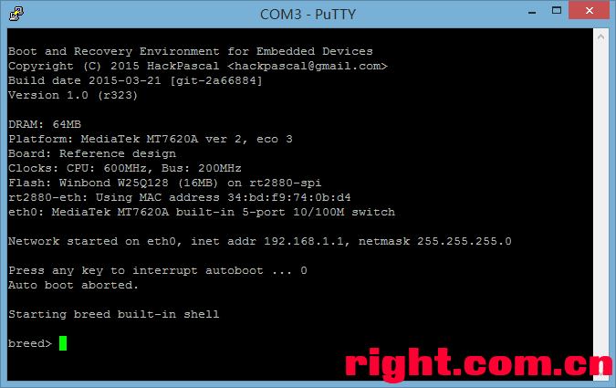

Breed Command console function description
- vt100 console compatible
- Supports 10 historical commands, which can be recalled using the up and down keys
- Each command supports up to 1024 characters
- Left and right keys, Home/End keys move the cursor, and can insert and delete characters.

Breed Introduction to built-in commands
[abstatus]
Syntax: | abstatus
Action: | Shows the reason why automatic start was interrupted

[arp]
Syntax: | arp
Action: | Show current ARP table

[boot]
Syntax: | boot mem <addr>
 | boot flash [bank <n>] <addr>
 | boot linux <addr>
 | boot raw <addr>
 | boot breed <addr>
Parameter: | <addr> – Start address
 | <n> – Flash bank Number
Explanation: | Start the firmware.
 | boot mem – Boot firmware from memory address;
 | boot flash – Starts the firmware from Flash, the bank number is optional, and the default is 0;
 | boot linux – Regards <addr> as the Linux kernel entry address and starts;
 | boot raw – Disables interrupts and executes from <addr>;
 | boot breed – Regards <addr> as the address of the uploaded Breed.bin file and starts it directly.

[btntst]
Syntax: | btntst
 | btntst enable <n>
 | btntst disable <n>
 | btntst restore
Parameter: | <n> – GPIO number
Explanation: | Test GPIO buttons
 | btntst enable – Enable status detection for GPIO#n
 | btntst disable – Disable status detection for GPIO#n
 | btntst restore – Restore default detection settings

[dhcp]
Syntax: | dhcp
 | dhcp [enable|disable]
Explanation: | Show current DHCP lease
 | dhcp enable – Enable DHCP service
 | dhcp disable – Disable DHCP service
 | Changes will not be saved, and the default DHCP on state will be restored after restarting.

[env]
Syntax: | env
 | env list
 | env get <key>
 | env set <key> <value>
 | env unset <key>
 | env clear
 | env save
Parameter:
 | <key> environment variable name
 | <value> environment variable value
Explanation: | Manage environment variables
 | Environment variables must be enabled using envconf before you can use this command
 | Environment variables must be saved after modifying them
 | env list – Lists all environment variables, displays total space and free space
 | env get – Gets the value of the environment variable named <key>
 | env set – Sets the value of the environment variable <key> to <value>, if it does not exist, create a new one
 | env unset – Deletes the environment variable named <key> and its value
 | env clear – Clears all environment variables
 | env save – Saves environment variables

[envconf]
Syntax: | envconf
 | envconf disable
 | envconf <addr> <size>
Parameter:
 | <addr> The storage location of environment variables in Flash, starting from 0
 | <size> environment variable size, cannot be less than 0x100 bytes
Explanation: | Enable or disable environment variables
 | envconf disable – disables the environment variable function
 | Specify <addr> and <size> to enable environment variables
Notice: | Some models of Breed use fixed environment variable settings, so this command is not available.

[exit]
Syntax: | exit
Explanation: | Exit telnet mode

[flash]
Syntax: | flash list
 | flash [bank <n>] info
 | flash [bank <n>] dump <addr> <size>
 | flash [bank <n>] read <addr> <dst> <size>
 | flash [bank <n>] erase <addr> <size>
 | flash [bank <n>] write <addr> <src> <size>
Parameter: | <n> – Flash bank number
 | <addr> – Flash address
 | <size> – Read/Erase/Write data size
 | <src> – The memory address of the data to be written to Flash
 | <dst> – The memory address to store the read Flash data
Explanation: | flash list – Lists all Flash
 | flash info – Displays flash details
 | flash dump – Displays the data in Flash
 | flash read – Reads the data in Flash into memory
 | flash erase – Erase Flash
 | flash write – Writes memory data to Flash

[gpio]
Syntax: | gpio [status|list]
 | gpio button
 | gpio led
 | gpio get <n>
 | gpio set <n> <hi|lo>
 | gpio dir set <n> <in|out>
 | gpio led set <name> <on|off>
Parameter: | [status] – List all GPIOs and their status
 | <n> – GPIO number
 | <hi> <lo> – High/Low level
 | <in> <out> – GPIO direction is input/output
 | <name> – LED name
 | <on> <off> – LED on/off
Explanation: | gpio [status|list] – List all GPIOs and their status
 | gpio button – Displays the status of the button on the current route
 | gpio led – Displays the status of some LEDs on the current route
 | gpio get – Gets the level status of the specified GPIO
 | gpio set – Sets the level state of the specified GPIO
 | gpio dir set – Sets the direction of the specified GPIO
 | gpio led set – Sets the LED on and off

[help]
Syntax: | help
Explanation: | List all available commands

[mem]
Syntax: | mem dump [keep] <start_addr> [size]
 | mem crc32 <addr> <size>
 | mem read [byte|short|long] <addr>
 | mem write [byte|short|long] <addr> <value>
 | mem write str <addr> <str>
 | mem copy <dst> <src> <size>
 | mem fill <dst> <val> <size>
 | mem compare <addr1> <addr2> <size>
Parameter: | [keep] – Keep original byte order
 | <start_addr> <addr> <addr1> <addr2> – starting address
 | <size> [size] – Displayed/calculated data size
 | [byte] [short] [long] – Specifies the operand size, which are 1 byte, 2 bytes, and 4 bytes respectively.
 | <value> – The value to write
 | <str> – The string to be written, supports C language type encoding
Explanation: | mem dump – Displays memory data, you can specify the number of bytes to be displayed, keep means to save the original byte order, otherwise it will be converted to CPU byte order when output.
 | mem crc32 – Calculates the CRC32 check of memory data
 | mem read – Reads the value of an address in the memory
 | mem write – Modifies the value of an address in memory
 | mem write str – Writes – a string to a memory address
 | mem copy – Copies memory blocks
 | mem fill – Fills the memory block
 | mem compare – Compares memory blocks

[mdio]
Syntax: | mdio list
 | mdio <dev> dump <phy>
 | mdio <dev> read <phy> <reg>
 | mdio <dev> write <phy> <reg> <val>
Parameter: | <dev> – Device name
 | <phy> – PHY issue
 | <reg> – Register
 | <val> – Numeric value
Explanation: | mdio list – Lists network interface devices
 | mdio dump – Dumps the MII register of the specified interface (0 ~ 31)
 | mdio read – Reads the MII register of the specified interface
 | mdio write – Modifies the MII register of the specified interface

[net]
Syntax: | net [start|stop]
Explanation: | net start – Starts the network service
 | net stop – Stops network services and closes all network connections

[netstat]
Syntax: | netstat
Explanation: | Shows currently active network connections

[reset]
Syntax: | reset
Explanation: | Restart routing

[setbrg]
Syntax: | setbrg <val>
Parameter: | <val> – Baud rate
Action: | Set the baud rate of Breed serial port output, always valid

[spi]
Syntax: | spi list
 | spi [dev <slave>] <op> [<op> [<op> ...]]
Parameter: | <slave> – SPI device name
 | <op> – Operation
Operation type:
 | start | Start an SPI transmission, that is, pull the CS level low
 | stop | End SPI transmission, that is, raise the CS level
 | read <addr> <size> | Read data into memory
 | read display <size> | Read data and display directly in hexadecimal format
 | write <addr> <size> | Write the data in the memory address
 | write str <str> | Write <str> string
 | speed <speed_str> | Set the SPI bus frequency. The default unit is Hz, you can add the suffix k/m to represent KHz/MHz
Explanation: | spi list – Lists all SPI devices
 | The spi command can be followed by multiple operations, such as:
 | spi start write "\x9f" read display 3 stop

[sysinfo]
Syntax: | sysinfo
Explanation: | Show system information

[thread]
Syntax: | thread
Explanation: | List all thread information

[wget]
Syntax: | wget [addr] <url>
Parameter: | [addr] – The memory address where the data is to be stored, can be ignored
 | <url> – HTTP link to request file data
Explanation: | Load files into memory via HTTP protocol. Only IP addresses can be used in the URL.

[U-Boot] U-Boot Flashing Method
This post was last edited by hackpascal on 2016-10-24 14:19
https://www.right.com.cn/forum/thread-154561-1-1.html

U-Boot Flashing Methods

1st Floor: OpenWrt + SSH Flashing Method
2nd Floor: U-Boot + TTL Flashing Method
3rd Floor: Upload files using HFS (with 1st floor method)

OpenWrt + SSH flashing method
If you want to flash U-Boot, you must flash in the OpenWrt firmware that unlocks the U-boot partition beforehand.

Preparation tools:
PuTTY: http://www.chiark.greenend.org.uk/~sgtatham/putty/download.html
WinSCP: http://winscp.net/eng/download.php

PuTTY can act as an SSH client and log into the router's shell environment to execute various commands.
WinSCP is a graphical SCP protocol (SSH-based file transfer protocol) client for local and routed file transfers.

Set the OpenWrt admin password (root password):
You can only use the SSH protocol tool if you have set the root password.
If you've already set a password, skip this step.

Just choose one of the following steps

1. Set an admin password in LuCI (for firmware with LuCI):
[System] → [Stewardship]
2. Set a password using telnet login routing (for firmware without LuCI):
The telnet protocol is a protocol similar to SSH, except that it is not encrypted, making it less secure in an extranet environment.
OpenWrt can only use the telnet protocol if the root password is not set.

PC [Start] → [All Programs] → [Accessories] → [Command Prompt]
or
Win+R key combination → enter cmd → enter

input telnet <Router IP address>

input passwd enter
Enter the password twice, each ending with a press return.
Note: When you enter the password, the password will not be displayed, just enter it directly.

Use WinSCP to transfer files to be flashed (using U-Boot as an example):

Open WinSCP
File Protocol selects SCP
Enter the Host name as the IP address of the router
Enter root in User name
Password Enter the password of root

Click [Login]

If it is the first time to log in to the WinSCP route, WinSCP will pop up the following dialog:
It is to the effect that the host is connected for the first time, and its RSA fingerprint key is not registered, whether or not to trust the host
Click Yes here to confirm that you trust this route.

WinSCP main interface
On the left, switch to the directory of the file you want to upload
Switch to the /tmp directory on the right
The /tmp directory was chosen because the /tmp directory is mounted in memory and has a large capacity, so that the firmware will not conflict with Flash when flashing.

Select the file you want to upload, right-click and select [Upload]

Directly click [OK] to continue
The file can then be uploaded to the route.

Using PuTTY Login Routing:

Open PuTTY
Enter the Host Name as the IP address of the router
Connection type Select SSH (default)

Click [Open]

As with WinSCP, if it's the first time you're using PuTTY to log in to a route, you'll get the following prompt:
Click [Yes].

PuTTY will then ask for a username and password:
Enter root for your username
Fill in the root password. The same here will not be displayed when entering a password.
If the username and password are correct, you will be entered into the shell environment.

input cd /tmp command to the /tmp directory.

input mtd write <file name> <mtd partition name> command to flash the machine

The following diagram is an example of flashing U-Boot:

Some tutorials will add the -r parameter to the end of the mtd command, which means that the route will be restarted immediately after the flashing is complete
However, this is not recommended, as there is still a chance to remedy the mistake in selecting the wrong flashing file.

About getting the MTD partition name:
run cat /proc/mtd command

U-Boot + TTL flashing method
This method works with any U-Boot.
Preparation tools:
PuTTY: http://www.chiark.greenend.org.uk/~sgtatham/putty/download.html
TFTPd32: http://tftpd32.jounin.net/tftpd32_download.html
TFTPd32 is a TFTP (Simple File Transfer Protocol) server for transferring files to U-Boot.

Use PuTTY to enter U-Boot command-line mode via serial port:
Please find the relevant information on your own here

To set PC network parameters:
You need to set the IP address of the local NIC to a static IP address to transmit data through U-Boot

1. Check the IP address information in U-Boot:
Run on the U-Boot command line printenv command

ipaddr stands for U-Boot, which is the IP address used by the route
serverip represents the IP address used by the server, i.e., the PC

Here you need to change the local IP to the IP address of the serverip

To set the TFTP server parameters:
Open TFTPd32
Current Directory Select the directory where you want to upload the file
Server interfaces: Select the NIC to which the machine is connected to the route (refer to the IP address you just set)

Use the tftpboot command in U-Boot to get the file:
The tftpboot command is used to request files from the TFTP server and is stored in memory
The tftpboot command can be abbreviated as tftp without ambiguity

tftp <memory address> <file name>

In MIPS architectures, memory addresses start at 0x80000000 and are generally chosen as 0x80000000 because this allows as much memory as possible

A successful file transfer is marked by a Loading: sequence #
There may be a checksum bad prompt, which does not affect the data transfer.
If a T occurs every 10 seconds, the communication time out, and you need to check whether the network connection and IP address are correct.

Bytes transferred = The first digit after is the number of bytes of data transferred, in decimal, and the hexadecimal size in parentheses is the corresponding hexadecimal size, which will be used later.

Erase Flash in U-Boot:
Any kind of Flash has a wipe block size, and the erase size must be an integer multiple of this size, or if it is not, it must be aligned.

For example:
The common erase block size for SPI Flash is 64KB and the hexadecimal number of bytes is 0x10000
If the erase size is 0x30000 (192KB), this size is an integer multiple of 0x10000, aligned;
If the wipe size is 0x12345 (72KB), the size is misaligned, and you need to use a larger but closest size that is a multiple of 0x10000, which is 0x20000 (128KB).

erase <flash address> +<erase size>

The Flash address is different for different chips, which will be listed later

Take flashing U-Boot in a TP-Link route as an example:

erase 0x9f000000 +0x20000

Write data to Flash in U-Boot:
The size of the data written to Flash can be any positive integer

cp.b <source address> <destination address> <length>

thereinto
cp.b stands for writes in bytes

The source address is the address where the file data obtained by the tftpboot command is stored
The destination address is a Flash address
The length is the size of the file retrieved by the tftpboot command, expressed in hexadecimal format with a 0x prefix

Take flashing U-Boot in a TP-Link router as an example:

cp.b 0x80000000 0x9f000000 0x20000

The starting address and size of each component of the common routing firmware:

TP-Link Firmware:
 | U-Boot | firmware | ART
4M | Flash address:  0xbf000000 (AR71xx, AR913x) /  0x9f000000 (AR724x and later)  Size: 0x20000 | Flash address:  0xbf020000 /  0x9f020000  Size: 0x3c0000 | Flash address:  0xbf3f0000 /  0x9f3f0000  Size: 0x10000
8M | Flash address:  0xbf000000 (AR71xx, AR913x) /  0x9f000000 (AR724x and later)  Size: 0x20000 | Flash address:  0xbf020000 /  0x9f020000  Size: 0x7c0000 | Flash address:  0xbf7f0000 /  0x9f7f0000  Size: 0x10000
16M | Flash address:  0xbf000000 (AR71xx, AR913x) /  0x9f000000 (AR724x and later)  Size: 0x20000 | Flash address:  0xbf020000 /  0x9f020000  Size: 0xfc0000 | Flash address:  0xbfff0000 /  0x9fff0000  Size: 0x10000
32M  (Only the landlord does not die U-Boot) | Flash address:  0xbf000000 (AR71xx, AR913x) /  0x9f000000 (AR724x and later)  Size: 0x20000 | Flash address:  0xbf020000 /  0x9f020000  Size: 0x1fc0000 | Flash address:  0xc0ff0000 /  0xa0ff0000  Size: 0x10000

NETGEAR WNDR3700v2/WNDR3800/WNDRMAC:
Only U-Boot and ART, because the original factory upgrade firmware cannot be directly flashed
 | U-Boot |  | ART
16M | Flash address:  Size: | 0xbf000000  0x50000 | Flash address:  Size: | 0xbfff000  0x10000

AR2317 UBNT:
Only U-Boot and board_config, because the original factory upgrade firmware cannot be flashed directly
Only works with the landlord's undead U-Boot
 | U-Boot |  | ART
4M | Flash address:  Size: | 0xa8000000  0x30000 | Flash address:  Size: | 0xa83f000  0x10000
8M | Flash address:  Size: | 0xa8000000  0x30000 | Flash address:  Size: | 0xa87f000  0x10000
16M | Flash address:  Size: | 0xa8000000  0x30000 | Flash address:  Size: | 0xa8ff000  0x10000

AR7161 AR724x AR934x UBNT:
Only U-Boot and EEPROM/ART, because the original factory upgrade firmware cannot be flashed directly
 | U-Boot |  | ART
4M | Flash address:  Size: | 0xbf000000 (AR7161) /  0x9f000000 (AR724x and later)  0x40000 | Flash address:  Size: | 0xbf3f0000 /  0x9f3f0000  0x10000
8M | Flash address:  Size: | 0xbf000000 (AR7161) /  0x9f000000 (AR724x and later)  0x40000 | Flash address:  Size: | 0xbf7f0000 /  0x9f7f0000  0x10000

MT7620 public type firmware (U-Boot size is 192KB):
 | U-Boot | firmware | EEPROM
4M | Flash address:  0xbc000000 (Other U-Boot) / 0x9c000000 (U-Boot)  Size: 0x30000 | Flash address:  0xbc050000 / 0x9c050000  Size: 0x3b0000 | Flash address:  0xbc040000 / 0x9c040000  Size: 0x10000
8M | Flash address:  0xbc000000 (Other U-Boot) /  0x9c000000 (U-Boot)  Size: 0x30000 | Flash address:  0xbc050000 /  0x9c050000  Size: 0x7b0000 | Flash address:  0xbc040000 /  0x9c040000  Size: 0x10000
16M | Flash address:  0xbc000000 (Other U-Boot) /  0x9c000000 (U-Boot)  Size: 0x30000 | Flash address: 0xbc050000 /  0x9c050000  Size: 0xfb0000 | Flash address: 0xbc040000 /  0x9c040000  Size: 0x10000
32M  (Only the landlord does not die U-Boot) | Flash address:  0x9c000000  Size: 0x30000 | Flash address:  0x9c050000  Size: 0x1fb0000 | Flash address:  0x9c040000  Size: 0x10000

Use HFS to upload files
If you find it troublesome to upload files using WinSCP, you can consider uploading files in the HTTP way, that is, setting your PC as an HTTP server and downloading files on the route.
If you already have an HTTP server on your PC, you can directly store the file you want to upload in the HTTP root directory and download it with the wget command on the router.

Preparation tools:
HFS: http://www.rejetto.com/hfs/?f=dl

HFS is a lightweight HTTP File Server

To configure HFS:
Configuring HFS is as simple as specifying the listening IP address and the files you want to download.
[Menu] → [IP address] Select the IP address of the local NIC

In the context menu of Virtual File System on the left, Add files... and select the file you want to upload.

Download files in the route:
Refer to the method on the first floor and use SSH or telnet to enter the route
execute cd /tmp Go to the /tmp directory
execute wget http://<HFS listening IP address>/<file name> to download the file

As:
wget http://192.168.1.2/u-boot-tp9343.bin

TTL Flashing Instructions
First, please refer to the post U-Boot flashing method to build an HTTP file server using HFS

1. Transfer files:
Execute the command wget http://<Computer IP address>/<File name>

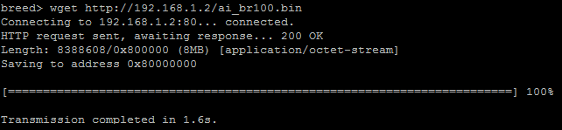

Record the Memory address after Saving to address and the Data size starting with 0x after Length:
Here the Memory address is 0x80000000, and the Data size is 0x800000

2. Erase Flash:

Please determine the erase address and size according to the actual situation

Execute the command flash erase <Start address> <Erase size>

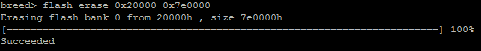

3. Data input:

Execute the command flash write <Flash address> <Memory address> <Data size>
<Memory address> is the address recorded in the first step

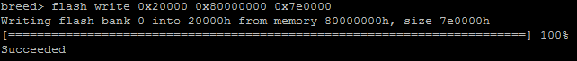

Reset button test instructions

First, use the method on the 4th Chapter (“Breed command console instructions and TTL flashing”) to enter the Breed command console.

Then execute the command btntst

Then you can press the button on the router. Each time you press or release the button, there will be a line of output.

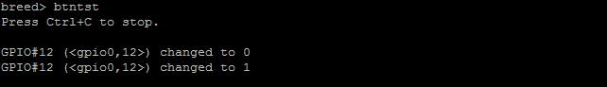

The data after GPIO# in the first column is the GPIO number of the current button.
The second column is for the GPIO definitions in the OpenWrt dts file
Finally, the GPIO status

If the button is pressed, the GPIO status is 0. When released, the status is 1, indicating that the button is active-low, otherwise it is active-high.

If a certain GPIO level change continues to be output after running the btntst command, you can execute the command first

btntst disable <n>
<n> is the continuously changing GPIO number
Then execute the btntst command, so that you can ignore the detection of the status of GPIO <n>

btntst enable <n>
Resume detecting the status of GPIO <n>

btntst restore
Restore the initial GPIO status detection settings (it will be restored after restarting)

Environment variable description
Environment variables in Breed need to be set before they can be used.
But note: Some models of Breed and NAND-started Breed use fixedly set environment variables, so there is no environment variable setting page and envconf command!
And Breed of WDR6500v2 does not support environment variables due to size reasons!
To determine whether a Breed supports environment variables, please directly observe whether the "Environment Variable Editing" page exists in the Breed Web recovery console, or execute the env command in the Breed command line. If the "Environment Variable Editing" page or the env command exists, it indicates this Breed supports environment variables!

There is an Environment variable Settings page in the Breed Web recovery console. Please set it according to the prompts on the page.

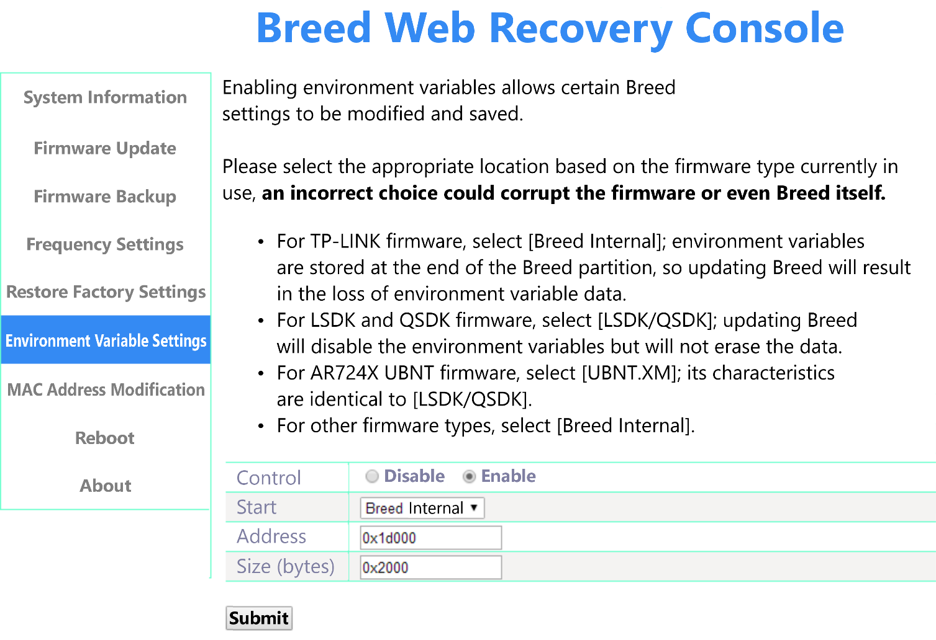
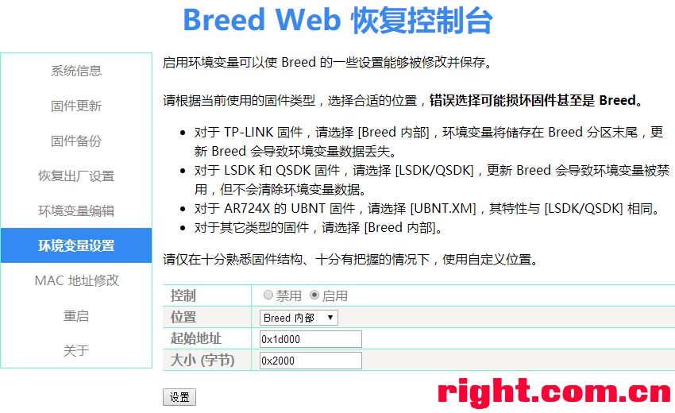

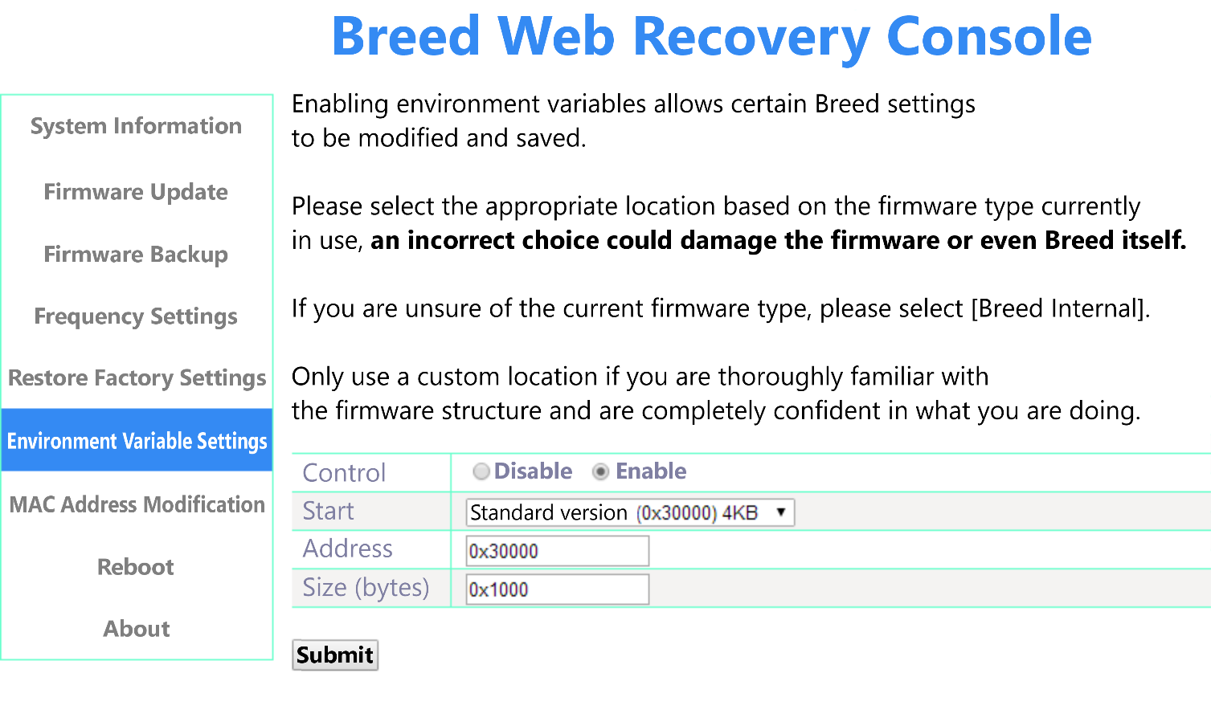
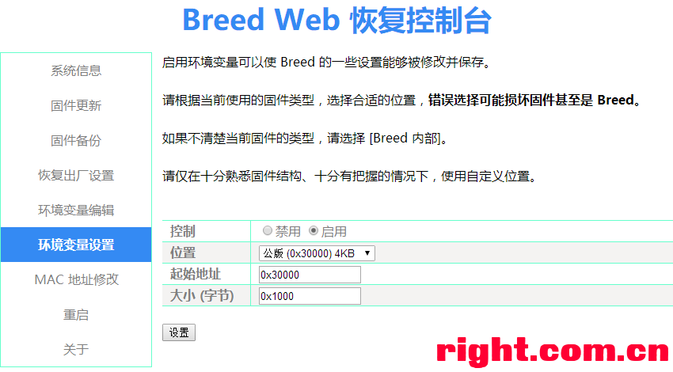

There is an Environment variable Editor in the Breed Web recovery console:
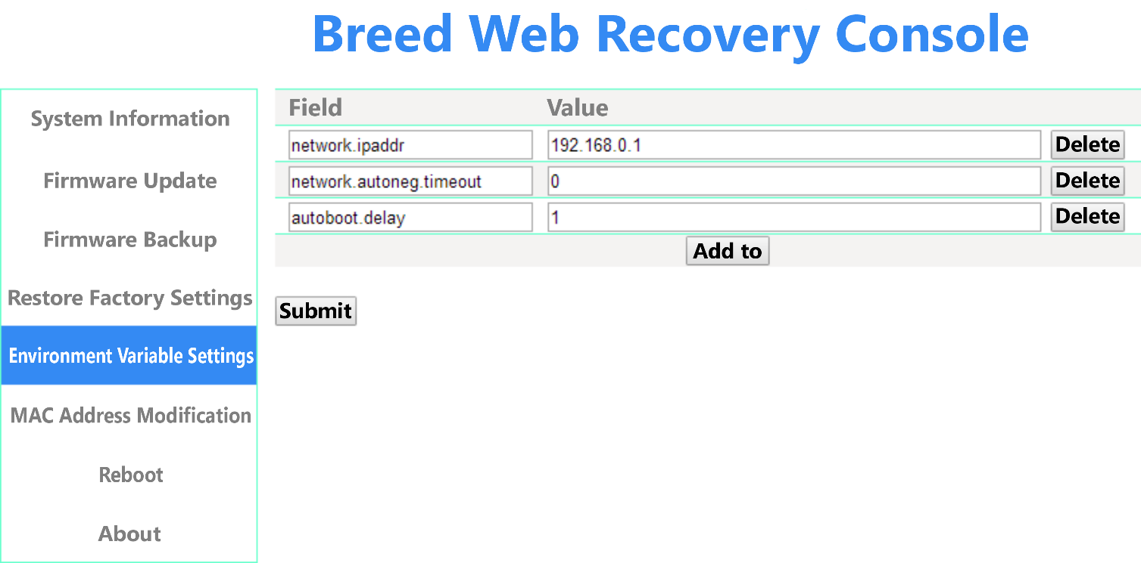
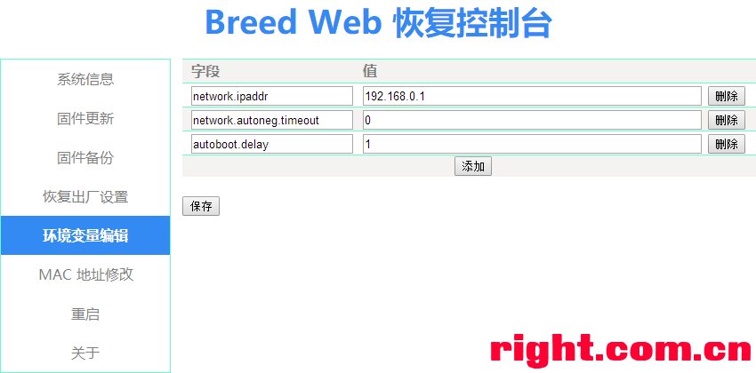
Environment variables can also be modified using commands

Environment variables that can be set:

network.ipaddr
Breed's IP address
Example: env set network.ipaddr 192.168.1.1

network.netmask
Breed's subnet mask
Example: env set network.netmask 255.255.255.0

network.dhcpd.disabled
Disable DHCP server. Set to 1 to disable, other values to enable
Example: env set network.dhcpd.disabled 0

network.autoneg.timeout
Ethernet PHY auto-negotiation waiting time, range 0-10, 0 means no waiting
Example: env set network.autoneg.timeout 5

sys.led_blink.disabled
Disables SYS LED Heartbeat blinking. Set to 1 to disable, other values to enable
Example: env set sys.led_blink.disabled 0

autoboot.disabled
Disable auto-start, do not start the firmware, and enter Breed command line/flash mode directly. Set to 1 to disable, other values to enable
Example: env set autoboot.disabled 1

autoboot.delay
Automatic start waiting time, must be greater than 0
Example: env set autoboot.delay 5

autoboot.command
Automatic start command, can contain multiple commands, use half-width semicolon; to separate
Example: env set autoboot.command "boot mem 0x9f020000"

linux.cmdline
Linux kernel command line
Example: env set linux.cmdline "console=ttyS0,115200 root=31:02 rootfstype=squashfs,jffs2 init=/sbin/init"
If you want to use the autoboot command, you need to execute env unset linux.cmdline to disable the custom kernel command line

linux.initrd.start
initrd starting address
Example: env set linux.initrd.start 0x80400000

linux.initrd.size
initrd size
Example: env set linux.initrd.size 0x500000

gpio.customized.reset
Specify a custom reset button configuration (only valid for a few special versions of Breed)
Explanation: The data format is number + activity status. The number is the GPIO number. Please execute the gpio command to view the valid GPIO number. The activity status is a letter and is not case sensitive. L means active-low and H means high level active (active-high)
Example: env set gpio.customized.reset 11L

If you want to restore the default settings of a certain setting, execute env unset to delete the corresponding environment variable name.

Please save after modification!!!

Custom reset button description

Only valid for files whose file names end with -blank
Such files do not contain any GPIO configuration, so the boot cannot be interrupted by pressing the reset key when first flashed.
This type of Breed therefore does not support custom overclocking functions.
How to use it:
First interrupt the startup through BreedEnter, or directly interrupt through the serial port.
Then enable environment variable support through Breed Web
Finally, set the effective reset key by setting the environment variable and save it.
Please refer to the instructions above for environment variable settings.

Xiaomi Mini firmware startup settings

Enter the Breed recovery console

Enter the Firmware Startup Settings page
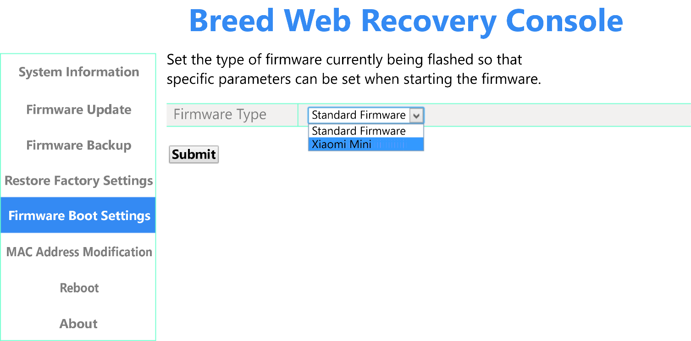
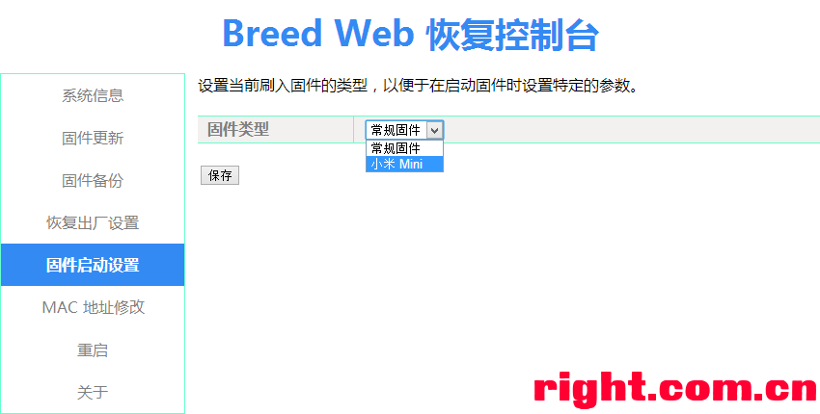

Select the firmware type as Xiaomi Mini and save it.

Then you can start the Xiaomi Mini original firmware perfectly.
And can log in using serial port (TTL)

Changelog
[2022-07-24 r1416]
– Rewrite the entire Web UI update framework:
  - Improved NAND support: All versions that use NAND now support comprehensive bad block management, including automatic skipping of bad blocks during upgrades and automatic skipping of bad blocks when backing up the programmer firmware. At the same time, the function of upgrading the firmware of the NAND programmer is practical (Starting with this release, Breed will only support upgrading "upgradeable programmer firmware" that is backed up by the new version of the backup programmer firmware feature).
  - More flexible upgrade file options: Some models now support upgrading files other than bootloader, firmware, ART/EEPROM, such as separate kernel/rootfs or machine factory key.
  - More firmware backup options:
  - For NAND machines, two types of programmer firmware are supported: upgradeable programmer firmware and RAW data Both of these programmer firmware data contain OOB data. Among them, the upgradable programmer firmware is eliminated according to the partition table, and ECC is turned on during backup Raw data is the raw data in the NAND, with ECC not enabled, and bad block data retained
  - Depending on the model, some models will provide a backup function for specific partitions
Not all models will use the new web UI immediately, and those that have been used will be listed later. The rest will be updated gradually

- Fixed an issue where the MT7621 NAND driver read data incorrectly in some cases
- Added support for XM25QH128C
- The HC5962/B70 Dedicated Edition supports backing up and upgrading bdinfo
- Xiaomi R3G supports direct upgrade of kernel1 and rootfs0 of OpenWrt firmware; Now OpenWrt, Padavan and the factory firmware boot from kernel1 by default The PandoraBox firmware boots from kernel0 by default; Support for backing up and updating Bdata partitions; Environment variables share the same partition as the original factory
- The DW33D Dedicated Edition supports upgrading and booting NAND versions of the OpenWrt firmware
- Added Pole Router 4Pro HC5961 Dedicated Edition, which uses 512MB memory timing by default
- Added ZTE E8820S Dedicated Edition, which supports Pole Routing 4 HC5962/B70 firmware; Firmware that supports MTK SDK partitioning; Support to start the original firmware and upgrade the original programmer firmware
- Models using the new web UI have their version numbers upgraded to 1.2

Updated files:
- breed-ar9344-wndr4300-nand.bin
- breed-ar9344-wndr4300-spi.bin
- breed-ar9344-wndr4300-spi-recovery.bin
- breed-mt7621-creativebox-v1.bin
- breed-mt7621-hiwifi-hc5961.bin
- breed-mt7621-hiwifi-hc5962.bin
- breed-mt7621-r6220.bin
- breed-mt7621-xiaomi-r3g.bin
- breed-mt7621-zte-e8820s.bin
- breed-qca953x.bin
- breed-qca9558-dw33d.bin
- breed-qca9563-dir-859-a.bin
- breed-qca9563-wndr4500v3.bin
- breed-rt3052-hg255d.bin

Explanation:
- Xiaomi R3G If you want to directly upgrade the kernel1 and rootfs0 of OpenWrt, you need to select the flash layout as "Xiaomi R3G OpenWrt"; If you want to upgrade for Bdata, you need to select the flash layout as "Xiaomi R3G Original".
- The DW33D requires you to choose whether to boot OpenWrt from NAND or from SPI-NOR on the Firmware Boot Settings page. When switching back to the original firmware from the OpenWrt firmware, you need to restore the factory settings once at the same time to avoid the error of mounting jffs2 on the original firmware
- All dedicated editions that use NAND only support upgrading OpenWrt's – factory.bin, not TAR-type – sysupgrade.bin.
- Due to the author's work and limited energy, the remaining models will be gradually updated to version 1.2. In addition, if the dedicated version of TP-Link exceeds the file size limit, it will stop updating
- The MTK SDK firmware partition table supported by E8820 is: 512k (u-boot), 512k (u-boot-env), 256k (factory), 4096k (kernel), -(ubi).

[2021-12-16 r1338]
- Fixed the bug that the environment variables of MT7621 NAND version could not be used
Updated files:
- breed-mt7621-hiwifi-hc5962.bin
- breed-mt7621-r6220.bin
- breed-mt7621-xiaomi-r3g.bin

[2021-12-15 r1337]
- Fixed the bug that MT7621 NAND bad block table status value was incorrect, resulting in the inability to read/write any data
- Disable the MT7621 JTAG so that the LED using the JTAG pin can light up properly
- Some SPI-NOR support (EN25QX128/MX77L12850F/XM25QW128C/XT25F128B, etc.) has been added

[2021-12-12 r1333]
- The Flash framework and drivers have been completely rewritten, and the programmer mode has been added
- NAND driver completes bad block processing. (Yes.) MT7621/AR9344/QCA9558 and other NAND machines, including SPI-NAND with WNDR4500v3/QNDR4300v2).
- Fixed the issue that the AR9344 NAND driver was unstable, and the WNDR4300v1 NAND version was re-added
- Old chips come back to life, and all of them are re-added and updated (except for individual chips).
- DW33D Special Edition fixes the environment variable location bug, and now the u-boot-env partition is always used, no need to set it again

[2020-10-09 r1286]
- Fixed the bug that MT7621 DDR frequency recognition may be incorrect
- Fixed the MT7621 system bus frequency calculation method, and fixed the SPI frequency inaccuracy issue

[2020-01-14 r1280]
- Added JD Cloud Router (RE-SP-01B) Special Edition, which supports direct flashing of original firmware and Breed write protection

[2019-12-29 r1274]
- Fixed a bug in the SPI-NAND driver that caused write errors on Micron SPI-NAND with >=256MB

[2018-12-29 r1266]
- Gehua GHL-R-001 Special Edition uses UART1 instead
- Added D-Link DIR-859 A1/A2 dedicated version
- WRTnode2R Dedicated Edition added
- The spi command adds the ability to set the frequency

[2018-12-23 r1260]
- Fixed the bug that MT7621/MT7628/MT7688 used some [firmware with old raspi driver] causing Breed to be erased and cause bricking
- (Continuing from the previous article, it is known that OpenWrt/PandoraBox/new versions of Padavan do not have this problem).

[2018-12-15 r1258]
- Added JHR-848Q special edition
- Added Gehua GHL-R-001 special edition
- Added GRENTECH SGR-W500-N85b v2 special edition (this version supports RTL8211E).
- ADDED A DEDICATED VERSION OF ROSINSON WR818
- The MT7621/MT7628/MT7688 uses the new SPI driver
- By default, the USB power of Newifi D2 is turned off, and if you need to turn it on, please set the ambient variable newifi-d2.usb_pwr_en=1
- Atheros SDK flash layout that supports firmware without NVRAM partitioning (i.e., permissible firmware size +64KB).
- Fixed an issue where the DW33D Dedicated Edition might not be able to flash the OpenWrt firmware (see the previous article).

[2018-10-14 r1237]
- Added Newifi D2 dedicated edition
- Fixed the bug that MT7621/MT76X8 SPI Flash driver may be unstable under 32M flash

[2018-08-05 r1226]
- Newifi D1 has USB power turned on by default
- Added XMC SPI-NOR flash support

[2018-06-12 r1220]
- Fixed the bug that after flashing the firmware such as OpenWrt in the Phicomm K2T Special Edition, the SQUASHFS error occurred when the firmware was started

[2018-06-10 r1219]
- Fixed the bug that the MAC address data was not written when flashing the programmer firmware to "Keep Bootloader" in the Phicomm K2T Special Edition

[2018-05-28 r1218]
- Fixed the bug that the PHICOMM K2T special edition could not start the firmware after flashing the programmer firmware

[2018-05-27 r1217]
- Add Phicomm K2T Dedicated Edition
- Fixed MT7621 NAND ONFI probing function
- Fixed the bug that the QCA956X general version could not automatically start the firmware

[2018-03-23 r1211]
- Add Netgear R6220 Dedicated Edition
- Add Netgear WNDR3700 v5 Dedicated Edition
- Add the spi command
- Extend the functionality of MEM commands
- Boosts the read speed of the ATH79 series SPI
- Re-enable the Config partition wipe function and add a security check (if the EEPROM is lost due to mis operation, please bear the consequences).

[2018-01-08 r1169]
- Polar Router 4/HC5962/B70 Dedicated Edition adds support for flashing and booting the original firmware, and adds support for environment variables

[2017-12-26 r1163]
- Fixed the bug that the AR/QCA series was stuck, and the boot was stuck when there was a valid MAC address (TP-Link type).

[2017-12-25 r1162]
- Ralink/MTK removes the Config partition wipe function
- Added Polar Route 4/HC5962/B70 Dedicated Edition
- Fixed the bug that the progress of the factory reset page of the Xiaomi Router 3G was undefined
- The boot command adds the ability to start Breed directly

[2017-09-21 r1126]
- Try to fix some MT7621 route 2.4G wireless loss or instability bug 2nd version (not all of them will work).
- Added CreativeBox v1 Dedicated Edition

[2017-09-19 r1121]
- MT7621 adds NAND support
- Added support for Mi Router 3G Private Edition
- QCA956X Added UART GPIO RX:19 TX:22 configuration dedicated version (reset key GPIO1/2).
- Try to fix some bugs (not all of them will work) where the MT7621 route 2.4G wireless is missing or unstable
- Added flashing prompt on the "Firmware Update" page of K2P / A3004NS Edition
- TOTOLINK A3004NS SPECIAL EDITION ADDS FACTORY FIRMWARE SUPPORT (AT THE SAME TIME, THE "A3004NS SETTINGS" PAGE IS ADDED, AND THE FACTORY FIRMWARE CAN ONLY BE STARTED WHEN THE DATA ON THIS PAGE IS VALID).
- The K2P Dedicated Edition reverts to the "Public 0x50000" default flash layout
- Add an environment variable editing page (no longer need to go to the Breed command line to edit environment variables).
- The dedicated version of TP-Link TL-WDR6500 v2 is no longer updated due to its size

[2017-08-31 r1080]
- WNDR4500 v3 Private Edition uses fixed environment variable settings
- Add the environment variable network.autoneg.timeout to set the waiting time for network port auto-negotiation

[2017-08-30 r1075]
- ADDED SUPPORT FOR TOTOLINK A3004NS DEDICATED EDITION
- Adds Netgear WNDR4500 v3 Dedicated Edition support
- QCA9563 Added QCA8337 support
- QCA956X Added dedicated editions for different UART GPIO configurations
- The AR/QCA series adds the LSDK/QSDK mac address setting page
- BelAir20E-11 Dedicated Edition updates web flashing page and firmware recognition
- Fixed the bug that MT7621 Breed could not start the PandoraBox firmware
- Fixed the bug that the EEPROM was lost due to the MTK selection of Feixun 0xA0000 flash layout update bootloader
- Added some new SPI-NOR Flash support
- Added SPI-NAND support

[2017-08-13 r1041]
- K2P uses the 0xA0000 flash layout by default
- Added a blank version of the AR913X AR9331 RT305X RT5350
- To avoid confusion, the firmware backup function was adjusted so that only the backup functions of ART/EEPROM and programmer firmware were retained

[2017-07-31 r1033]
- Fixed a bug that displayed the wrong size of the uploaded file
- Added support for PandoraBox PBR-M1 Dedicated Edition

[2017-07-28 r1028]
- The K2P Dedicated Edition sets the default memory AC timing to 512MB

[2017-07-27 r1027]
- MT7620 FIXES THE BUG THAT SDRAM MEMORY FREEZES WHEN RESTARTING
- MT7621 adds memory AC timing setting function
- The default memory AC timing of K2P Dedicated Edition is 256MB, so that it can directly support 128/256/512MB of memory

[2017-07-24 r1023]
- MT7621 fixes the bug that the network port fails on some devices
- MT7621 fixes the BUG of EEPROM positioning error (MAC address modification, backup EEPROM).
- MT7621 restores the memory frequency setting function
- K2P Special Edition modifies the default baud rate to 57600
- Fixed the bug that the network port failed when using the original firmware for K2P
- Re-added support for Newifi D1 Dedicated Edition

[2017-06-13 r1016]
- The MTK series adds a dedicated flash memory layout for Phicomm firmware

[2017-06-12 r1015]
- Fixed the K2P overclocking reset key definition error

[2017-06-11 r1014]
- MT7621 adds Feixun K2P support
- Removed WNDR4300 NAND Boot (breed-ar9344-wndr4300-nand.bin) support
- WNDR4300 SPI Boot (breed-ar9344-wndr4300-spi-recovery.bin) fix uncheck "Keep Bootloader" and "Keep Bootloader". ART" cannot flash any programmer firmware bugs
- The boot command extends the ability to start the Linux kernel and execute from an arbitrary address

[2017-04-16 r1010]
- MT7620 adds support for the new firmware version of PHICOMM K1/K2 (flashing and starting).

[2017-01-16 r1008]
- Fixed the bug that opened the Breed page on some systems and caused Breed to crash (the page is now unresponsive, pinging is not working), and all models are newer

[2016-12-19 r1006]
- The AR7161 adds IP1001 MV88E1116 BCM5481 Gigabit PHY support
- AR934X adds RTL8211E Gigabit PHY support
- Added Ethernet PHY auto-negotiation wait process to solve the problem that some Gigabit devices cannot use BreedEnter interrupt
- QCA956X-WDR6500V2 has been renamed to QCA9561-WDR6500V2
- Added support for OYE-0006 Special Edition
- Added AR7161 AR724X AR934X MT7620 MT76X8 No GPIO Configuration Special Edition, which can support a custom reset button (see description on the 6th floor).

[2016-10-01 r979]
- Update to version 1.1
- Added support for environment variables (see 6th floor of this post).
- Added support for the standalone WR941N v7 Dedicated Edition
- Added the abstatus command to show the reason why the startup was interrupted
- Added support for the new version of Fiscone K2 firmware (including boot part).
- Fixed a bug that Aruba-AP93 could not boot firmware
- Fixed the bug that WR941N v6 overclocking was invalid
- BreedEnter has added the ability to display the current IP address of Breed

[2016-08-25 r936]
- Fixed the bug of QCA9558 PHY address recognition
- Modified the HG255D EEPROM size detection limit to allow both 64KB and 128KB sizes
- Fixed a bug that the flash command could not display the SPI flash sector size
- The HG255D enables USB Energy Saving Mode

[2016-07-29 r928]
- Added parallel NOR Flash support (RT305X).
- Added support for D-Link DIR-605 B1 Special Edition (NOR).
- Added support for OR for HUAWEI HG255D
- Added RT305X + NOR RESET GPIO #0/#10 universal version

[2016-07-06 r899]
- Added support for Aruba-AP93 Dedicated Edition
- Added support for BelAir20E-11 Dedicated Edition (TP-Link and LSDK flash layouts only).
- Added support for Zhongwo ZM-10 special edition
- Fixed the detection of the Bootloader size of the DW33D/LSDK flash layout
- Fixed the bug that the DW33D original firmware WAN port could not be used

[2016-07-01 r890]
- Added support for RT305X SPI version (if I want to say a few times that routes do not support NOR, let me first make it clear that the support of HG255D is far away).
- Added support for Buffalo WCR-HP-CN dedicated edition (RT3050 SPI).
- Added support for D-Link DI-524M B1 (RT3050 SPI).
- Added support for Huamei A5 Dedicated Edition (RT5350).
- Added support for AR7242 + AR8021
- Added support for AR9342 + RTL8201 (Huawei WS322 Dedicated Edition), but with 10% packet loss
- Added support for Domy DW33D Edition
- Added QCA956X RESET GPIO #1/#2 Universal Edition
- Fixed the bug that QCA8337 could not be used
- Fixed the bug that AR8035 could not be used on QCA9558
- Fixed the bug that the input characters were repeated in some Telnet clients
- MT7620 adds Tomato Phoenix back to factory settings option
- Removed UniFi AP Dedicated Edition support
- Removed Newifi D1 Dedicated Edition support

[2016-04-19 r849]
- DIR-825 B1 adds OpenWrt fat firmware support
- Add Phicomm PSG1208/1218 Special Edition
- Fixed the issue that MT7620/MT76X8 restarted memory recognition error
- Fixed an issue where the MAC address input page might not be able to enter numbers or letters in the last two groups
- QCA9558 Added AR8035 (RGMII) and AR8033 (SGMII) support, self-identification (not tested).

[2016-03-18 r840]
- Adds RT5350 support (AirMobi iPlay Private).
- Add AirMobi iPlay2 Dedicated Edition

[2016-1-23 r833]
- Added Youku Roubao YK-L2 special version support
- Adds AR913X support (Gigabit 88e6060 General Edition).
- Added support for TP-Link TL-WR1043ND v1 Dedicated Edition
- Added AR7161 support (D-Link DIR-825 B1 Dedicated Edition).
- Fixed AR934X support for AR8035
- If you need AR7161 + AR8035 support, please contact the landlord

[2015-12-07 r802]
- Added LETV router special edition support
- AR934X/QCA953X/QCA955X/QCA956X/TP9343 Replace the SPI Flash driver to speed up Flash operation

[2015-11-03 r791]
- Fixed the issue that AR/QCA may fail to reboot and fail to boot firmware when using 32M Flash (only for Breed, not for firmware).
- Added TP-Link TL-WR800N support
- Fixed a bug where TL-WDR6500 v2 caused data corruption when flashing bootloaders larger than 63kb
- Modified OYE-0001 to default baud rate of 115200
- Rename AR724X-UBNT to AR724X-UNIFI-AP
- The AR724X adds separate support for RESET GPIO 11 and RESET GPIO 12

[2015-10-18 r777]
- Added OYE-0001 support
- Added support for Pinshengyun Drama WMP002N
- Fixed MT7620/MT7628/MT7688 memory recognition may be inaccurate
- Fixed MT7620 + SDRAM (FIR300M/302M) unstable bug starting from r645

[2015-09-21 r766]
- Fixed a bug that the AR724X may not be able to upgrade the firmware through UBNT Web after flashing the UBNT firmware

[2015-09-20 r765]
- Added support for some new Flash models
- Fixed a bug in the AR/QCA boot firmware

[2015-09-11 r761]
- Added support for the special version of Thunderbolt Time Machine
- The AR/QCA series adds flash layout support for the Atheros LSDK firmware
- QCA953X Added LeTV router firmware support (since there is no such route, there is no special version support).
- MT7620 adds support for Xiaomi Mini firmware SN and bdata backup
- Fixed the bug that AR9341 may not boot WNDR2000 v4 original firmware

[2015-09-08 r755]
- Added MT7621 (Newifi D1) support
- The AR724X adds the ability to disarm Flash write protection at boot to support the latest UBNT firmware (tested on UBNT XM 5.6.2).
- Replace the Flash driver of MT7628/MT7688 to speed up the read and write speeds
- MT762X adds 0x60000 flash layout support
- All dedicated models add the system status indication LED flashing function when entering web console mode; Lights up the power LED when it starts normally

[2015-08-21 r717]
- Added MT7688 support
- Fixed the VLAN issue that MT7628 might cause network disconnection in Breed
- Support for MW300R v6 is discontinued

[2015-08-06 r708]
- Added Netgear WNR2000 v4 support
- Added TP-Link TL-WDR6500 v2 support
- Added memory stability for AR934X
- Fixed the PCI-E initialization bug under QCA9558 to solve the problem that 5G wireless is not available

[2015-07-28 r679]
- Add WNDR4300 support (see post https://www.right.com.cn/forum/thread-170402-1-1.html for details).
- Added stability of firmware backup
- Increase the reliability of the wget command connection

[2015-07-19 r647]
- Added firmware update support for new Xiaomi mini versions

[2015-07-17 r646]
- Fixed the bug that MT7620 memory capacity detection error

[2015-07-13 r645]
- Added MT7628AN support (MT7628KN not yet tested) to support the new version of the Extreme One S HC5661A
- AR724X adds Netgear WNR1000 v2 support (does not support flashing the original firmware).
- Fixed the AR724X PCI-E initialization bug and solved the problem that there was no wireless
- Fixed the bug that the MAC address of the AR/QCA series was read incorrectly
- Fixed a bug that crashed when the Flash model was not recognized

[2015-06-04 r623]
- AR724X adds UBNT support

[2015-06-03 r615]
- Adds AR7242 + RTL8367R support (TL-WR2543ND Gigabit wired).
- Fixed a bug in the AR/QCA SPI that could cause an error in flashing the firmware

[2015-06-01 r610]
- Added support for the AR7240/AR7241 (the AR7242 currently only supports built-in single-port 100 Gigabit switches).
- Fixed a bug in MT7620 that I don't know what the impact is (wired network).

[2015-05-27 r599]
- AR9342/AR9344 adds support for AR8035 (self-identification).
- Fixed an issue where AR/QCA may have an error reading Flash

[2015-05-13 r585]
- Add AR9341 support
- Adds AR9342 + AR8327 support (TP-Link TL-WR1041N v2 Dedicated Edition).

[2015-05-12 r576]
- Fixed the issue that the network port LED of AR9331 was displayed abnormally under Breed
- Adds TP9343 support
- Adds QCA9558 + AR8327N support (100 Gigabit Adaptive).
- Added Pole Router Pole One (HC6361) dedicated edition, only TP-Link type firmware is supported

[2015-05-07 r547]
- Adds QCA9558 + AR8236 support (100 Gigabit only).
- Adds AR9331 support
- Fixed the issue that the firmware could not be backed up
- Fixed the issue that the frequency setting was displayed abnormally in Firefox

[2015-05-04 r531]
- Add QCA953X support

[2015-05-03 r527]
- Adds AR9344 + AR8327N Gigabit support
- Added Mercury MW4530R Edition

[2015-04-29 r520]
- Add Pole Router Pole III (HC5861) Dedicated Edition, Gigabit LAN is available

[2015-04-28 r515]
- Set switch port isolation to prevent the PC from directly acquiring the IP address of the higher-level route at boot time

[2015-04-26 r511]
- Added support for AR9344 Gigabit Edition to support custom overclocking
- MT7620 adds RippleOS factory reset function
- Fixed the issue that it could not be uploaded under Linux
- Fixed the issue that the wrong IP address was obtained after the firmware was started

[2015-04-07 r446]
- Added Pole Router Pole II (HC5761) Edition
- Set the MT7620 CPU default frequency to 580MHz
- Add overclocking

[2015-04-06 r433]
- Fixed a bug that could not be used on 256MB of memory
- Added Lenovo Y1S (newifi) dedicated version, which supports dual Gigabit ports
- Add Phicomm FIR300M/302M dedicated edition

[2015-04-04 r425]
- Added iKuai firmware boot support
- Improved Xiaomi Mini firmware boot support (see 6th floor for instructions).
- Add the dedicated version of Xiaomi Mini
- Fix the issue that the firmware can't be booted again

[2015-04-03 r419]
- Add Youku Routing Treasure Special Edition
- Fixed the issue that firmware could not be backed up under 32M Flash (mainly Youku Roubao).
- Fixed the issue that the firmware could not be booted occasionally

[2015-04-02 r411]
- Add 3 dedicated editions

[2015-03-31 r408]
- Fixed the issue that the firmware could not be booted on some routes (ZTE Q7).
- When entering flash mode, all LAN port LEDs flash

[2015-03-30 r396]
- Fixed the issue that Xiaomi Mini entered Breed when it was booted
- Fixed the issue that some factory firmware could not be soft rebooted

[2015-03-30 r393]
- Added GPIO#26 reset key support (ZTE Q7 Portable 3G Wireless Router).
- Improved MT7620 btntst commands

[2015-03-29 r389]
- Fixed an issue where the PandoraBox firmware could not be started on Lenovo's router (Y1, Y1S, RY-1, etc.) or kept restarting after booting
- Added Youku Routing Treasure firmware flashing and startup support
- Added Buffalo WHR-1166DHP factory reset support
- Flashing via PandoraBox U-Boot is supported

[2015-03-24 r372]
- Added support for MT7620 routing with external PA

[2015-03-24 r353]
- Fixed the issue that some factory firmware wired networks could not be used

[2015-03-23 r346]
- Fixed the issue that the LED was fully lit
- Fixed some bugs in the GPIO test function of the reset key
- Fixed an issue where the MT7620 frequency was displayed incorrectly
- Fixed the issue of jumping to /cgi-bin/luci
- Added Buffalo WHR-1166DHP support (reset key only).

[2015-03-21 r323]
- Test the first version

